Tutorial - 5
Measures of Dispersion: Variance and Standard Deviation

we are going to learn about a very important topic in Statistics called the Measures of Dispersion.
In previous lessons, we discussed 'Measures of Central Tendency' (Mean, Median, and Mode), which tell us about the "center" of the data. However, knowing just the center isn't enough. We also need to know how much our data is "spread out" from that center.

What is Measure of Dispersion?
Dispersion simply means "Spread." It tells us how far or how close the data points are from their average (Mean).
Definition:
Measures of Dispersion are statistical tools that show the spread or variety within a distribution of data.
To understand this, we primarily use two tools:
- Variance
- Standard Deviation

1. Variance
Variance tells us the size of the spread. It is the average of the squared differences from the Mean.
The Formula
In Statistics, we look at this in two ways depending on our data group:

Type | Symbol | Formula
Population Variance | σ² (Sigma Squared) | σ² =$\frac{∑(X-μ)2}{N}$​
Sample Variance | s² | s²= $\frac{∑(X-Xˉ)2}{n-1}$​
- µ or $Xˉ$:The average (Mean) of the data.
- n - 1: This is called Bessel's Correction. We use n-1 for samples to make our calculations more accurate for the real world.

2. Standard Deviation
Because we "square" the differences in Variance, the number often becomes very large. To bring it back to the original scale, we take the square root.
Definition
Standard Deviation is the square root of the Variance. It is the most commonly used measure of spread.
Formula: $Standard Deviation = $\sqrt{Variance}$
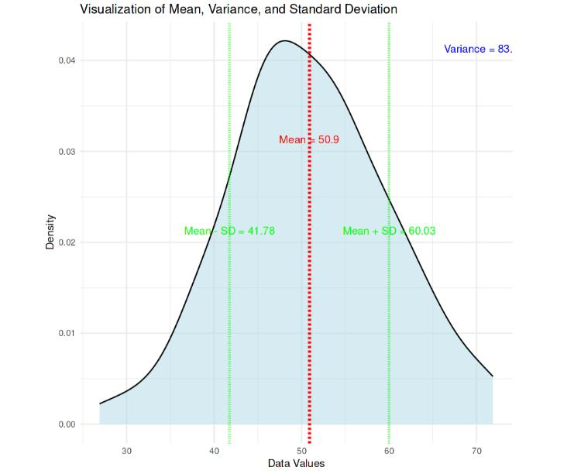

🧮 Step-by-Step Calculation Flowchart
Calculating these values follows a specific logical sequence. Use this flowchart to guide your work:
Example Calculation
Let's take a small dataset of student marks: {1, 2, 2, 3, 4, 5} (Total 6 points).
- Find the Mean: $Xˉ$ = $\frac{(1+2+2+3+4+5)}{6}$ ≈ 2.83

- Calculate Variance: Subtract 2.83 from each number, square the result, add them up, and divide by n-1 (which is 5).
Simple Variance s² = $\frac{∑(X-Xˉ)2}{n-1}$​
👉 Step by step How to Calculate Variance
Data: 1, 2, 2, 3, 4, 5
Step I: Mean $(Xˉ)$ = 2.83
Step II: Calculate (X – Mean)
X | X - 2.83
1 | -1.83
2 | -0.83
2 | -0.83
3 | 0.17
4 | 1.17
5 | 2.17
Step III: Square values
Value | Square
-1.83 | 3.35
-0.83 | 0.69
-0.83 | 0.69
0.17 | 0.03
1.17 | 1.37
2.17 | 4.71

Step IV: Sum $∑=10.84$

Step V: Variance s² =$\frac{10.84}{6-1}=\frac{10.84}{5}=2.168$
​

- Standard Deviation: $\sqrt{2.16}$ ≈ 1.47
What does this mean?
It means most data points are located within a distance of 1.47 from the average (2.83).

How Variance Affects the Curve
The visual "shape" of your data depends entirely on its dispersion.
- If Variance is High: The data is very spread out. The curve will look wide and flat.
- If Variance is Low: The data is very close to the average. The curve will look thin and tall.
[Image comparing a high variance curve (broad and flat) with a low variance curve (narrow and tall)]

Key Takeaways (Summary)
- Dispersion: Measuring the spread of data.
- Variance: The average of squared distances from the mean.
- Standard Deviation: The square root of variance. It tells us how much data "deviates" from the average.
- Usage: In Data Science, we prefer data with a Low Standard Deviation if we want consistency.
Practice Question:
If the Variance of a dataset is 25, what is its Standard Deviation?
Answer: $\sqrt{25}$ = 5

Final Revision Summary
- Descriptive Statistics describes what you have; Measures of Dispersion describe how spread out it is.
- Always remember to use n-1 for Sample Variance.
- Standard Deviation allows you to see the "jumps" (1SD, 2SD, 3SD) on a normal distribution graph.
Happy Learning! Keep practicing with different sets of numbers to master these formulas!

